|  |  |
| --- | --- |
| Innovative Storage Management  ITRI 613 | Enrico Dreyer  31210783 |

Table of Contents

Introduction 2

Software-Defined Storage 2

HP 2

IBM 2

NetApp Inc. 2

VMware Inc. 3

Coraid 3

DataCore 3

Why use SDS as an innovative solution for storage? 3

How it works 4

Advantages 4

Summary 5

References 5

# Introduction

In this assignment, six Vendors that offer Software-Defined Storage will be discussed, as well as their key advantages in terms of security, speed, and cost. There will also be a discussion on the process of how a traditional enterprise can adopt Software-Defined Storage as an innovative solution for storage, and what the tradeoffs will be of doing so.

# Software-Defined Storage

In 2013 Software-Defined Storage (SDS) was proposed to be a new category that falls under storage software products (Carlson et al., 2014). SDS can function as a standalone technology, or as an element in a Software-Defined Data Centre.

SDS is a ‘marketing’ word that is a follow-on term used for Software Defined Networking, that is used to describe an approach that is used in network technology to abstract different elements of networking to create a virtualized layer or abstraction layer in software. Whereas SDS represent a new evolution to the way that the industry stores data and how that data is deployed and managed in the future (Carlson et al., 2014).

Following will be a discussion on the Vendors that offer Software-Defined Storage, and what sets them apart (Technavio, 2015).

# HP

HP has been providing Software-Defined Storage and has had a Software-Defined Data Centre since the concept started. This is also one of the only vendors that is capable of delivering all elements that is part of software-defined data centre, these elements include networking, compute, management, and storage. They can also offer a complete SDS vision strategy based on openness simplicity, and efficiency. Where storage availability is their top priority.

They are also considered cheap as their enterprise feature set that can deliver the performance and capability of that of a traditional SAN. In terms of security, they provide a low cost on their data protection while delivering an efficient, fast, and scalable backup of all your data that requires no dedicated hardware.

# IBM

IBM specialises in the new era of cloud applications and environments, this includes mobile, social, and analytics. They also focus on cost-effectively optimizing their storage environments and finding new opportunities to lower their customers budgets.

For a company they are the perfect solution to increase efficiency and agility as their Spectrum Storage enhances the efficiency and speed of storage and allows for a simple way to migrate new workloads.

# NetApp Inc.

This Vendor establishes a market that is sizeable in terms of SDS space. NetApp offers cluster Data ONTAP PS, NetApp FlexArray, NetApp OnCommand and NetApp FAS series.

They also have multiple hardware options that include hardware deployment support with a wide variety of enterprise platforms. But due to having multiple hardware options, they have a higher chance of a security breach.

# VMware Inc.

By using application demands, VMware aligns storage with virtualized environments and strive to bring storage to the same optimal efficiency that server virtualization did to compute. The data plane that is responsible for the storing of data and using data services, by virtualizing and abstracting physical hardware resources, and combining them into pools of capacity.

They are different from other Vendors, as their method allows them to configure and control independently from each virtual machine that they use. Because the operation is so complex, it will take someone that really knows the system to be able to cause serious harm, thus making them very secure in that observation.

# Coraid

Coraid is embracing the fact that there is a rapid increasing of networking, storage, and the need for hardware to compute. This led them to embrace the shift from the traditional IT strategies and go for more of a highly automated and virtualized infrastructures.

This makes them different from other vendors as they are trying something way different. This led to them having an early lead in SDS, so they have a little bit more experience than the rest. But when there is something new, there are new security risks, thus making them an easy target for someone that want to cause hard to their system.

# DataCore

DataCore is one of the most reliable in software-defined storage. They are very user friendly and allows users to seamlessly scale and manage their data storage architectures, as well as gain massive performance deliverance.

Their cost is very low compared to other vendors and their budget on security is very high, thus making them cheap and reliable. They are also expanding rapidly, and that brings the users closer to the servers and increasing the speed in which they work in.

# Why use SDS as an innovative solution for storage?

In this part of the assignment, the how a traditional enterprise adopt SDS as an innovative solution for storage. As well as investigate what the trade-off of doing so is.

According to DataCore (2021) using SDS allows a company to easily expand, replace, and upgrade their storage hardware, without the need for uprooting the old operational procedures or changing the valuable software investments.

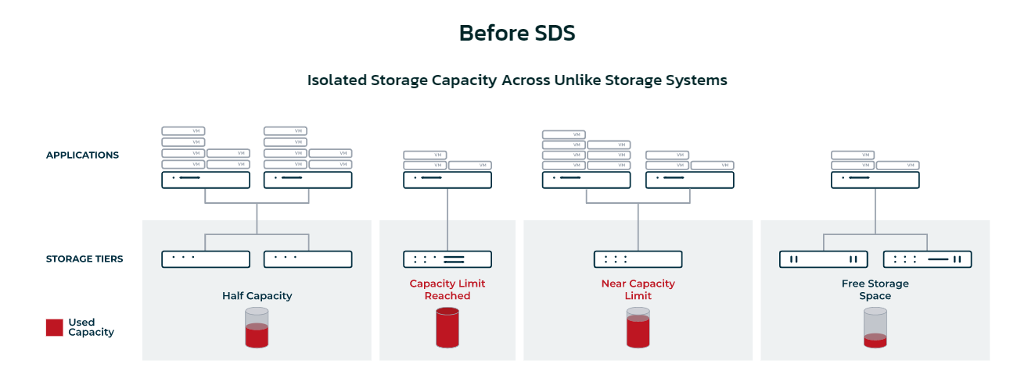

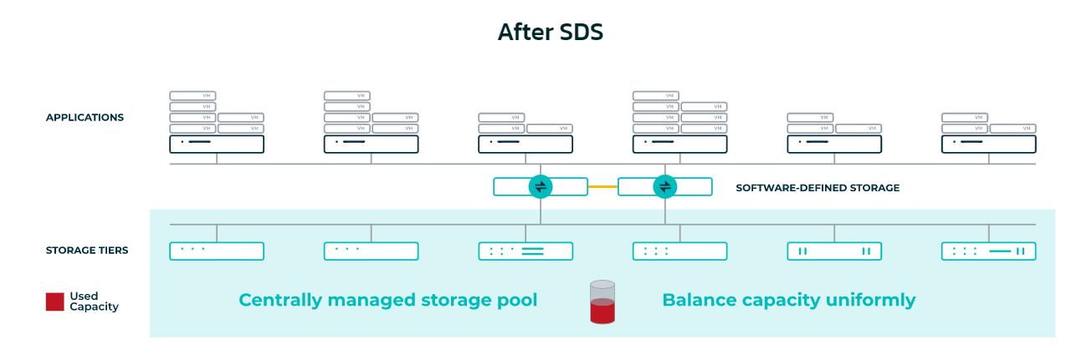

As shown in the images above, there are clear advantages of using Software-Defined storage. Below is the comparison between not using SDS and using SDS. By using SDS many companies can discard some of the challenges of data storage, such as high costs, migrations that are complex, issues in latency and storage downtime.

|  |  |
| --- | --- |
| **Not using SDS** | **Using SDS** |
| Monolithic and siloed storage architecture. | Centrally pooled and fluid storage architecture. |
| Rigid, hardware-bound storage infrastructure. | Ultimate freedom to choose any storage vendor/model/type. |
| Can run into vendor lock-in. | Non-disruptive storage refresh and data migration |

## How it works

One of the reasons why companies change their traditional storage methods to SDS is the ability to manage and consolidate all existing storage from one place, as well as facilitating diverse functionality and features (DataCore, 2021).

SDS is software that manages and virtualizes the company’s physical storage. All of the company’s storage will be consolidated into “virtual pools”.

## Advantages

In terms of efficiency, simplicity, and cost the differences are huge, for example:

* You get more out of existing storage investments.
* Gain flexibility that allows you to integrate new technology with equipment that you already have.
* Storage infrastructures are more effective with automated data placement, intelligence, and policy driven.
* The management control of storage capacity and provisioning allocation are controlled from a single control plane.

# Summary

The 6 vendors that offer SDS are HP, IBM, NetApp, VMware Inc., Coraid and DataCore. All of their advantages were discussed in terms of security, cost, and speed.

The process of how a traditional enterprise can adopt SDS as an innovative solution for storage was explored, as well as the advantages of doing so.

# References

Carlson, M., Yoder, A., Schoeb, L., Deel, D., Pratt, C., Lionetti, C., & Voigt, D. (2014). Software defined storage. *Storage Networking Industry Assoc. working draft*, 20-24.

DataCore. (2021). *Software-Defined Storage*. <https://www.datacore.com/software-defined-storage/>

Technavio. (2015). Top 12 Software-Defined Storage (SDS) Companies. <https://blog.technavio.com/blog/top-12-software-defined-storage-sds-companies>